German Unification
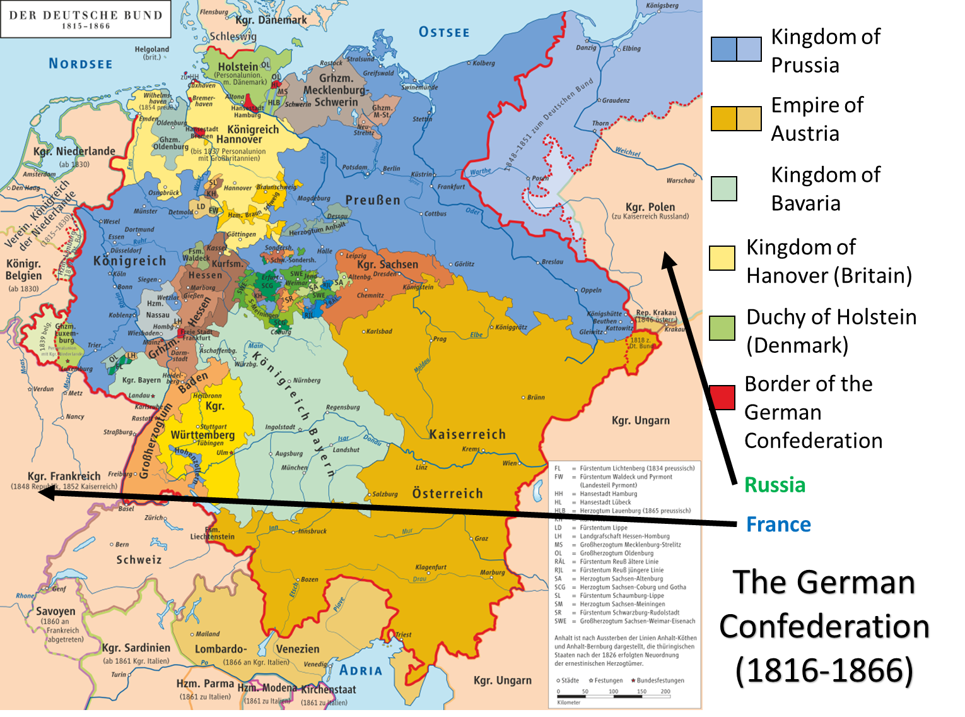
Source A: Map of the German Confederation (1816-1866)
What conclusions can we draw from looking at this map of Germany?

Secondary Source B: “Germany Before World War I”
- What was Germany like in the early 1800s?
- What caused the Unification of Germany in 1871?
- Describe some of the actions of the German chancellor, Otto von Bismarck.
- What happened when Wilhelm II became the German Kaiser (Emperor)? How did things change in Germany?
Primary Source C: Ernst Mortiz Arndt, The German Fatherland (1813)

WHERE is the German's fatherland?
The Prussian land? The Swabian land?
Where Rhine the vine-clad mountain laves?
Where skims the gull the Baltic waves?
Ah, no, no, no!
His fatherland 's not bounded so!
Where is the German's fatherland?
Bavarian land? or Stygian land?
Where sturdy peasants plough the plain?
Where mountain-sons bright metal gain?
Ah, no, no, no!
His fatherland's not bounded so!
Where is the German's fatherland?
The Saxon hills? The Zuyder strand?
Where sweep wild winds the sandy shores
Where loud the rolling Danube roars?
Ah, no, no, no!
His fatherland 's not bounded so!
Where is the German's fatherland?
Then name, then name the mighty land!
The Austrian land in fight renowned?
The Kaiser's land with honors crowned?
Ah, no, no, no!
His fatherland 's not bounded so!
Where is the German's fatherland?
Then name, then name the mighty land!
The land of Hofer? land of Tell?
This land I know, and love it well;
But, no, no, no!
His fatherland 's not bounded so!
Where is the German's fatherland?
Is his the pieced and parceled land
Where pirate-princes rule? A gem
Torn from the empire's diadem?
Ah, no, no, no!
Such is no German's fatherland.
Where is the German's fatherland?
Then name, oh, name the mighty land!
Wherever is heard the German tongue,
And German hymns to God are sung!
This is the land, thy Hermann's land;
This, German, is thy fatherland.
This is the German's fatherland,
Where faith is in the plighted hand,
Where truth lives in each eye of blue,
And every heart is staunch and true.
This is the land, the honest land,
The honest German's fatherland.
This is the land, the one true land,
O God, to aid be thou at hand!
And fire each heart, and nerve each arm,
To shield our German homes from harm,
To shield the land, the one true land,
One Deutschland and one fatherland!

1. What do you think Arndt means by the “fatherland”?
2. Where does Arndt believe the German’s fatherland is?
3. What does Arndt desire or want the German states to become?
Primary Source D: Otto von Bismarck Letter to Minister von Manteuffel (1856)

Because of the policy of Vienna [the Congress of Vienna, 1815], Germany is clearly too small for us both [Prussia and Austria]; as long as an honorable arrangement concerning the influence of each in Germany cannot be concluded and carried out, we will both [farm] the same disputed [land], and Austria will remain the only state to whom we can permanently lose or from whom we can permanently gain. . . .I wish only to express my conviction that, in the not too distant future, we shall have to fight for our existence against Austria and that it is not within our power to avoid that, since the course of events in Germany has no other solution.

Primary Source E: Field Marshal Helmuth von Moltke (1866)

The war of 1866 [between Prussia and Austria happened ] not because the existence of Prussia was threatened, nor was it caused by public opinion and the voice of the people; it was a struggle, long foreseen and calmly prepared for, recognized as a necessity by the Cabinet, not for [territory], for an extension of our [lands], or for material advantage, but for an ideal end--the establishment of power. Not a foot of land was [taken] from Austria, but she had to [give up] all part in the [leadership] of Germany. . . Austria had exhausted her strength in conquests south of the Alps, and left the western German provinces unprotected, instead of following the road pointed out by the Danube. Its center of gravity lay out of Germany; Prussia's lay within it. Prussia felt itself called upon and strong enough to assume the leadership of the German races.

Limited
Here Arndt is referring to the dozens of small German duchies and kingdoms. Germany is, in his view “in pieces”.
Holy Roman Empire
A hymn is a religious song, usually part of Christian tradition.

