The Significance of the French Revolution
Inquiry Question: How do we assess historical significance?
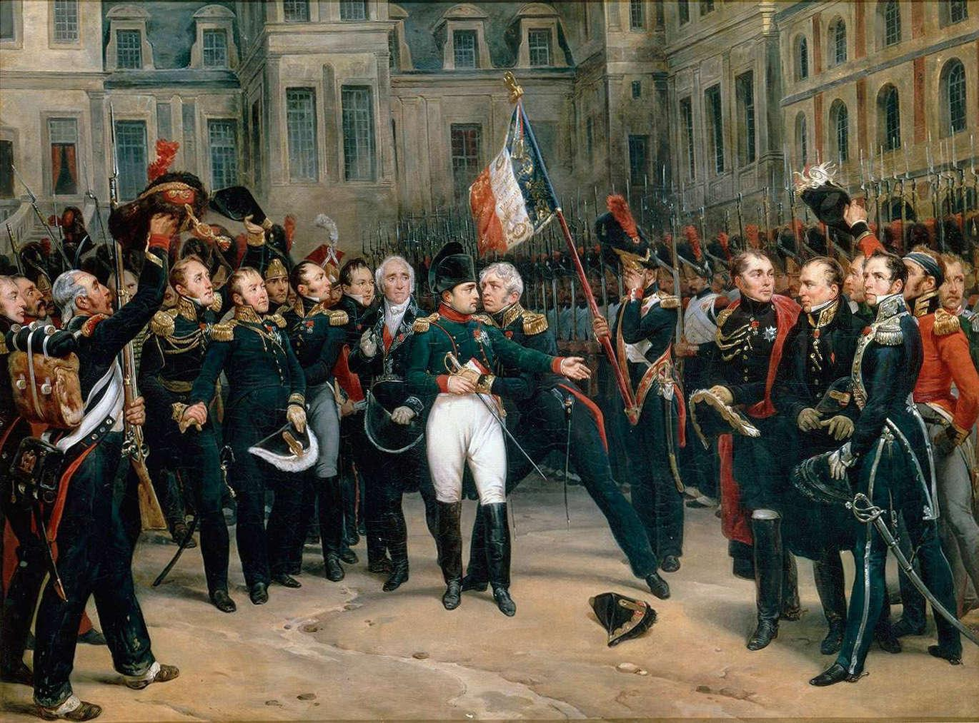
Napoleon saying goodbye to his soldiers in 1814.
“The French Revolution was a miserable failure.” Discuss.
Objective D: Thinking Critically
i. Discuss models, issues, theories, concepts, arguments, and visual representations.
Discuss means to give a “balanced” account or analysis of something. Clearly, the French Revolution is not a simple event in history. It had many positive outcomes, some negative outcomes, and it ended ultimately in another monarchy. However, it is important for us as historians to look at the big picture of an event and then to form our own conclusions. To help you organize your thoughts it will be beneficial to use a T-chart.

Agree | Disagree

“I may have had many projects, but I never was free to carry out any of them. It did me little good to be holding the helm; no matter how strong my hands, the sudden and numerous waves were stronger still, and I was wise enough to yield to them rather than resist them obstinately and make the ship founder. Thus I never was truly my own master but was always ruled by circumstances.”
- Napoleon Bonaparte (1816)

