Antisemitism in Nazi Germany
Criterion D: Thinking Critically
iv. Interpret different perspectives and their implications.
Source A: Mein Kampf (1925)
Mein Kampf was written by Adolf Hitler during his prison sentence in Landsberg Prison in 1925. It lays out Hitler’s ideological views and his ideas on antisemitism. A brief selection of his book is listed below. While you read, consider the following questions;
- Identify Hitler’s reasons for hating Jewish people.
- Summarize Hitler’s ideas in the second quotation. How might this be connected to genocide?

“The black-haired Jewish youth lies in wait for hours on end, satanically glaring at and spying on the unsuspicious girl whom he plans to seduce, [corrupting] her blood and removing her from the [chest] of her own people. The Jew uses every possible means to undermine the racial foundations of a subjugated people. In his systematic efforts to ruin girls and women he strives to break down the last barriers of discrimination between him and other peoples. The Jews were responsible for bringing [Africans] into the Rhineland, with the ultimate idea of bastardizing the white race which they hate and thus lowering its cultural and political level so that the Jew might dominate. For as long as a people remain racially pure and are conscious of the treasure of their blood, they can never be overcome by the Jew. Never in this world can the Jew become master of any people except a bastardized people.”
…
“If at the beginning of [World War One] and during the war twelve or fifteen thousand of these Hebrew [Jewish] corrupters of the nation had been subjected to poison gas, such as had to be endured in the field by hundreds of thousands of our very best German workers of all classes and professions, then the sacrifice of millions at the front would not have been in vain.”

Source B: National Socialist German Catechism
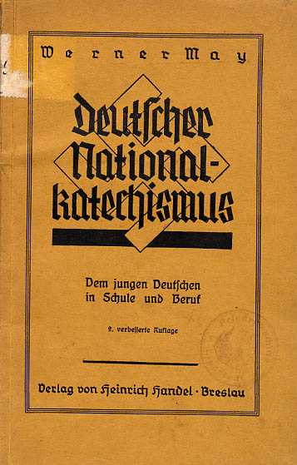
The following document was part of an instructional book used in schools throughout Nazi Germany. The book included the views of the Nazi Party on a variety of topics. A catechism is method of teaching belief or ideology, usually in the form of questions and answers that must be memorized.
The text below is from the section on “race”. It gives us a good idea of what the Nazis believed about race and how it was important to their view on German identity.
Instructions: Read the following source with a partner. While you read, take notes on;
- What the Nazis believed about race and identity.
- What this source reveals about Nazi antisemitism.

What is a race?
A group of living creatures is a race when its individual members share the same appearance and genetic inheritance.

What do I understand under “appearance and genetic inheritance”?
Physical characteristics that are passed along: the colour of the skin, the shape of the skull, and particularly facial features (shape of the nose, mouth, lips), etc.

What are the major races?
White, black, and yellow.

To which race do Europe’s peoples belong?
The peoples of Europe do not belong to a particular race but are rather a racial mixture. Our German people is comprised primarily of six races.

And what are they?
The Nordic, the Pfalzish, the Western European, the East Baltic, the Ostic and the Dinarish races.

What were and are the particular characteristics of the Nordic race?
Courage, bravery, creative ability and desire, loyalty.
The German people are, along with the English, Danish, Norwegian, and Swedish, the most racially pure of the European peoples. With regards to the purity of language, the Scandinavian peoples are in first place. Its Gothic script is particularly lovely, and it should be maintained.

Which race must the National Socialist race fight against?
The Jewish race.

Why?
The goal of the Jew is to make himself the ruler of humanity. Wherever he comes, he destroys works of culture. He is not a creative spirit, rather a destructive spirit.

How is that evident?
The work of Aryan peoples shows a true creative spirit. The Jew is mostly a merchant, as he was for millennia in the past. There are no Jewish construction workers in Germany, no smiths, no Jewish miners or seamen. Nearly all major inventions were made by Aryans.

How has the Jew subjugated the peoples?
With money. He lent them money and made them pay interest. Thousands and thousands of Germans have been made wretched by the Jews and been reduced to poverty. Farmers whose land had been in the family for more than 100 years were driven from their land because they could not pay the interest.

What happened to those farmers?
They had to move to the cities. Torn from the land to which they belonged, robbed of their labour that gave their lives purpose and meaning, they fell victim to poverty and misery. Worn down, their souls crushed, they accepted Jewish doctrines that denied the Fatherland and opposed all that was nationalistic. Their strength and ability faded. The Jew had reached his goal.

What other guilt does the Jew bear?
While the German people were fighting a life and death battle during the World War, the Jew incited people at home and seduced them into treason. The November Revolution of 1918 that brought about Germany’s collapse was the work of the Jew. In countless newspapers in Germany and abroad, he brought everything German into the mud, slandering us and inciting our enemies even more than they already were. His [followers] in leading positions in the Reich [mistreated] the National Socialist movement, bringing the fighters for a new Germany before judges and throwing them into prison. He corrupted Germans through bad books, and mocked true literature and German music, replacing it with un-Germanic music. Everywhere, his influence was destructive.

What is racial defilement?
Forgetting our spirit and our blood. A careless disregard of our nature and a contempt for our blood. No German man may take a Jewish woman as his wife, and no German girl may marry a Jew. Those who do that exclude themselves from the community of the German people.

What must the National Socialist movement do?
Adolf Hitler said: “Care must be taken, at least in our nation, that the deadliest enemy (the Jew) is recognized, and that the battle against him is seen as the shining symbol of a brighter day that will also show other peoples the path to the salvation of fighting Aryan humanity.”

What do your people mean to you?
You are born into your people, my child, of a German mother. Your father is a German. And you belong to the German people just as every part of your body belongs to you. You are a link in a great chain, a part of the whole. Alone, you are nothing, but when you live for your people you are everything. Your people’s destiny is your destiny. Its struggles and sorrows, its joys and its miseries, are yours. All Germans are your brothers. You may not think, want or do anything that harms your people! The history of your people is great and glorious, and you can be proud of it. The days of betrayal and the years of shame that Germany had to endure between 1918 and 1933 are a warning to you. You must work and create for the resurrection of your Fatherland.

The greatness of your people calls you to loyalty! Never forget that Frederick the Great and Bismarck were your brothers, as are those heroes of the World War who sleep in foreign soil or in the depths of the sea! The war memorials in the streets of the cities and the marketplaces of the villages call to you. Never forget that we cheerfully shed our blood for you, for Germany’s holy soil, for the good and the life of this great people!

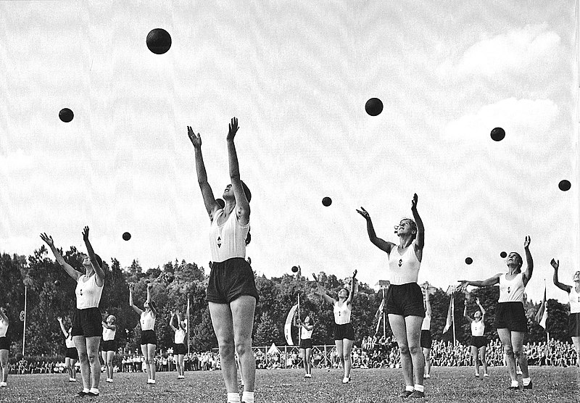

Source C: The Nuremberg Laws (1935)
I
n 1935 the Nazis passed a series of laws in the German Reichstag (parliament) with the intention of excluding Jews from German society. Together, these laws are known as the Nuremberg Laws because they were initially announced at a Nazi Party rally in the German town of Nuremberg.
Law for the Protection of German Blood and German Honour
Moved by understanding that purity of German blood is the essential condition for the continued existence of the German people, and inspired by the inflexible determination to ensure the existence of the German nation for all time, the Reichstag has unanimously adopted the following law, which is promulgated herewith:
Objective D: Thinking Critically
iv. Interpret different perspectives and their implications.
Article 1
- Marriages between Jews and subjects of the state of German or related blood are forbidden.
Article 2
- Extramarital relations between Jews and subjects of the state of German or related blood are forbidden.
Article 3
- Jews may not employ in their households female citizens of German or related blood who are under 45 years old.
Article 5
- Any person who violates the prohibition under Article 1 will be punished with prison with hard labour.
Reich Citizenship Law
Article 2
- A Reich citizen is a subject of the state who is of German or related blood, and proves by his conduct that he is willing and fit to faithfully serve the German people and Reich.

Source D: Kristallnacht (1938)
O
n November 9th and 10th, 1938, members of the SA, SS and Hitler Youth destroyed Jewish businesses, set fire to synagogues, and assaulted Jews on the streets. In addition, 30,000 Jews were arrested and sent to concentration camps. In total, at least 91 Jews were killed, around 300 synagogues were destroyed, and 7,000 businesses damaged and vandalized. Historians consider Kristallnacht, meaning “night of broken glass”, as a turning point. It was the first, and only, incident of organized violence against the Jewish community before the outbreak of World War Two. However, it demonstrated the Nazi’s willingness to act with violence towards Jews.
Description of the Riot at Dinslaken, November 10th 1938
...I recognized a Jewish face. In a few words the stranger explained to me: "I am the president of the Jewish community of Duesseldorf. I spent the night in the waiting-room of the Gelsenkirchen Railway Station. I have only one request – let me take refuge in the orphanage for a short while. While I was traveling to Dinslaken I heard in the train that anti-Semitic riots had broken out everywhere, and that many Jews had been arrested. Synagogues everywhere was burning!"
With anxiety I listened to the man’s story; suddenly he said with a trembling voice: "No, I won’t come in! I can’t be safe in your house! We are all lost!" With these words he disappeared into the dark fog which cast a veil over the morning. I never saw him again.
In spite of this Job’s message I forced myself not to show any sign of emotion. Only thus could I avoid a state of panic among the children and tutors. Nonetheless I was of the opinion that the young students should be prepared to brave the storm of the approaching catastrophe. About 7:30 A.M. I ordered 46 people – among them 32 children – into the dining hall of the institution and told them the following in a simple and brief address:
"As you know, last night a Herr vom Rath, a member of the German Embassy in Paris, was assassinated. The Jews are held responsible for this murder. The high tension in the political field is now being directed against the Jews, and during the next few hours there will certainly be anti-Semitic excesses. This will happen even in our town. It is my feeling and my impression that we German Jews have never experienced such calamities since the Middle Ages. Be strong! Trust in God! I am sure we will withstand even these hard times. Nobody will remain in the rooms of the upper floor of the building. The exit door to the street will be opened only by myself! From this moment on everyone is to heed my orders only!"
After breakfast the pupils were sent to the large study-hall of the institution. The teacher in charge tried to keep them busy.
At 9:30 A.M. the bell at the main gate rang persistently. I opened the door: about 50 men stormed into the house, many of them with their coat- or jacket-collars turned up. At first they rushed into the dining room, which fortunately was empty, and there they began their work of destruction, which was carried out with the utmost precision. The frightened and fearful cries of the children resounded through the building. In a stentorian voice I shouted: "Children, go out into the street immediately!" This advice was certainly contrary to the orders of the Gestapo. I thought, however, that in the street, in a public place, we might be in less danger than inside the house. The children immediately ran down a small staircase at the back, most of them without hat or coat – despite the cold and wet weather. We tried to reach the next street crossing, which was close to Dinslaken’s Town Hall, where I intended to ask for police protection. About ten policemen were stationed here, reason enough for a sensation-seeking mob to await the next development. This was not very long in coming; the senior police officer, Freihahn, shouted at us: "Jews do not get protection from us! Vacate the area together with your children as quickly as possible!" Freihahn then chased us back to a side street in the direction of the backyard of the orphanage. As I was unable to hand over the key of the back gate, the policeman drew his bayonet and forced open the door. I then said to Freihahn: "The best thing is to kill me and the children, then our ordeal will be over quickly!" The officer responded to my "suggestion" merely with cynical laughter. Freihahn then drove all of us to the wet lawn of the orphanage garden. He gave us strict orders not to leave the place under any circumstances.
Facing the back of the building, we were able to watch how everything in the house was being systematically destroyed under the supervision of the men of law and order – the police. At short intervals we could hear the crunching of glass or the hammering against wood as windows and doors were broken. Books, chairs, beds, tables, linen, chests, parts of a piano, a radiogram, and maps were thrown through apertures in the wall, which a short while ago had been windows or doors.
In the meantime the mob standing around the building had grown to several hundred. Among these people I recognized some familiar faces, suppliers of the orphanage or tradespeople, who only a day or a week earlier had been happy to deal with us as customers. This time they were passive, watching the destruction without much emotion.
At 10:15 A.M. we heard the wailing of sirens! We noticed a heavy cloud of smoke billowing upward. It was obvious from the direction it was coming from that the Nazis had set the synagogue on fire. Very soon we saw smoke-clouds rising up, mixed with sparks of fire. Later I noticed that some Jewish houses, close to the synagogue, had also been set alight under the expert guidance of the fire-brigade. Its presence was a necessity, since the firemen had to save the homes of the non-Jewish neighborhood....
In the schoolyard we had to wait for some time. Several Jews, who had escaped the previous arrest and deportation to concentration camps, joined our gathering. Many of them, mostly women, were shabbily dressed. They told me that the brown hordes had driven them out of their home, ordered them to leave everything behind and come at once, under Nazi guard, to the schoolyard. A stormtrooper in charge commanded some bystanders to leave the schoolyard "since there is no point in even looking at such scum!"
In the meantime our "family" had increased to 90, all of whom were placed in a small hall in the school. Nobody was allowed to leave the place. Men considered physically fit were called for duty. Only those over 60 – among them people of 75 years of age – were allowed to stay. Very soon we learned that the entire Jewish male population under 60 had already been transferred to the concentration camp at Dachau. During their initial waiting period, while still under police custody, the Jewish men had been allowed to buy their own food. This state of affairs, however, only lasted for a few hours.
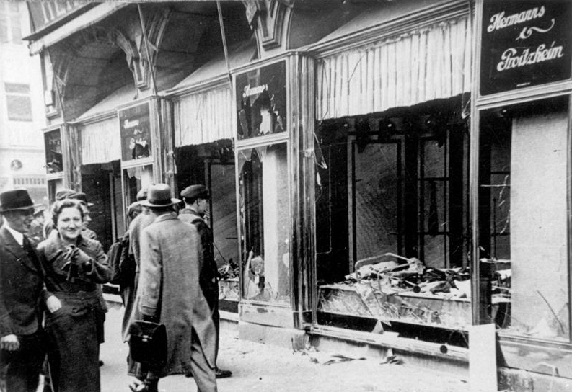
I learned very soon from a policeman, who in his heart was still an anti-Nazi, that most of the Jewish men had been beaten up by members of the SA before being transported to Dachau. They were kicked, slapped in the face, and subjected to all sorts of humiliation. Many of those exposed to this type of ill-treatment had served in the German army during World War I. One of them, a Mr. Hugo B.C., had once worn with pride the Iron Cross First Class (the German equivalent of the Victoria Cross), which he had been awarded for bravery....

This is a reference to the style of writing used in northern European cultures.
The Aryans were an ancient people the Nazis believed were the ancestors of the Germans. They believed the Aryans were a superior race of people. However, this is considered “pseudo-science” or “fake science” since there is no real evidence for the existence of the Aryans or relation between them and modern Germans.
Here the Nazis are referencing historical antisemitism. It is true that Jews were historically merchants and bankers, but this is only because they were excluded from other professions, including medieval guilds, because they were Jewish.
Job is a character from the Hebrew Torah (also found in the Christian Old Testament). In the story, Job is tortured by Satan and made to suffer. Job asks God why he allows him to suffer but receives no answer.
Ernst vom Rath was a German diplomat working in Paris in 1938. He was assassinated by a 17 year old Jew named Herschel Grynszpan. Herschel was angry because his family had been deported to Poland earlier in the year. The Nazis used vom Rath’s death as an excuse to launch Kristallnacht, however it is likely that they were already planning an act of violence before this event.
A reference to the Nazi SA or “stormtroopers”. Another Nazi paramilitary similar to the SS. These men were easily identified by their brown uniforms.

