History of Antisemitism: Cause & Consequence
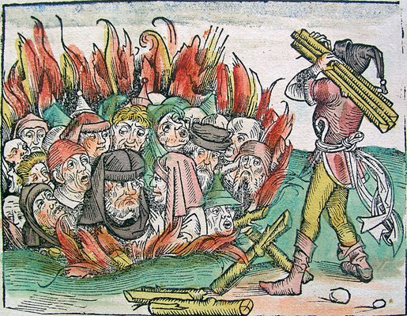
Instructions: Work in small groups to explore the primary sources below. These sources cover different eras in space and time. However, they all have one thing in common; they represent antisemitism.
Your task is to read each source and identify the reasons why the author expressed antisemitism. In other words, why did they hate Jews or hold prejudice against Jews?
Source A: Saint John Chrysostom tells followers to hate the Jews (400 CE).
The Jews sacrifice their children to Satan… They are worse than wild beasts. The synagogue is a brothel, a den of scoundrels, the temple of demons devoted to idolatrous cults, a criminal assembly of Jews, a place of meeting for the assassins of Christ, a house of [bad reputation], a dwelling of [disgusting behavior], a gulf and abyss of [hell]… The synagogue is a curse. [Stubborn] in her error, she refuses to see or hear; she has deliberately perverted her judgment; she has extinguished within herself the light of the Holy Spirit…
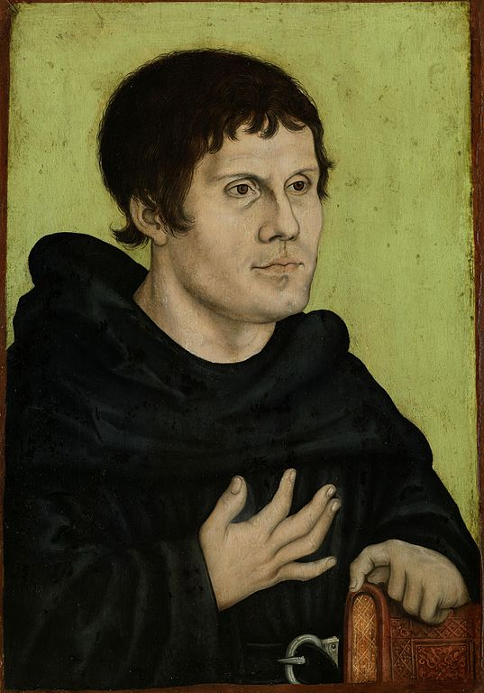
[The Jews] have fallen into a condition lower than the [most awful] animals. Debauchery and drunkenness have brought them to the level of the lusty goat and the pig. They know only one thing: to satisfy their stomachs, to get drunk, to kill and beat each other up like stage villains and coachmen… I hate the Jews, because they violate the Law [of Jesus]. I hate the Synagogue because it hates the Law and the Prophets. It is the duty of all Christians to hate the Jews.
Source B: Martin Luther, “On the Jews and their Lies” (1543).
Therefore a Christian should be content and not argue with the Jews. But if you have to or want to talk with them, do not say any more than this: “Listen, Jew, are you aware that Jerusalem and your sovereignty, together with your temple and priesthood, have been destroyed for over 1,460 years?” For this year, which we Christians write as the year 1542 since the birth of Christ, is exactly 1,468 years, going on fifteen hundred years, since Vespasian and Titus destroyed Jerusalem and expelled the Jews from the city. Let the Jews bite on this nut and dispute this question as long as they wish…
In short, as has already been said, do not engage much in debate with Jews about the articles of our faith. From their youth they have been so nurtured with venom and [hatred] against our Lord that there is no hope until they reach the point where their misery finally makes them [soft] and they are forced to [admit] that the Messiah has come, and that he is our Jesus. Until such a time it is much too early, yes, it is useless to argue with them about how God is [part of the Holy Trinity], how he became man, and how Mary is the mother of God. No human reason nor any human heart will ever grant these things, much less the embittered, venomous, blind heart of the Jews…
Source C: Henry Ford, “The International Jew” (1920).
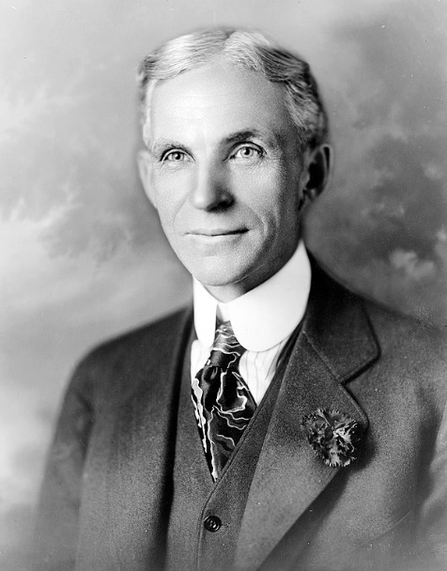
The Jew in Germany is regarded as only a guest of the people; he has offended by trying to turn himself into the host. There are no stronger contrasts in the world than the pure Germanic and pure Semitic races; therefore, there has been no harmony between the two in Germany; the German has regarded the Jew strictly as a guest, while the Jew, [angry] at not being given the privileges of the nation-family, has [become angry at] his host. In other countries the Jew is permitted to mix more readily with the people, he can [build] his control unchallenged, but in Germany the case was different. Therefore, the Jew hated the German people; therefore, the countries of the world which were most dominated by the Jews showed the greatest hatred of Germany during the recent regrettable war. Jewish hands were in almost [complete] control of the [the news media] by which public opinion concerning the German people was moulded. The sole winners of the war were Jews…

John Chrysostom was the archbishop of Constantinople during the period of the Roman Empire. He is considered one of the early Church fathers of Christianity.
A Jewish church or place of worship.
It is important to remember that medieval Christians accused Jews of being responsible for the crucifixion and death (circa 33 CE).
Titus was the Roman Emperor in 66 CE during the Jewish Rebellion. Vespasian was a future emperor but was a general in the army during the rebellion.
According to Christian belief, Jesus is the messiah – the one who will bring salvation to humanity. It is important to remember that Jews do not share this belief.
The Holy Trinity refers to the Christian belief that God, Christ and the Holy Spirit are one and the same being.
This is, of course, a reference to Germany’s defeat in the First World War.

