Unit 2: War and Violence
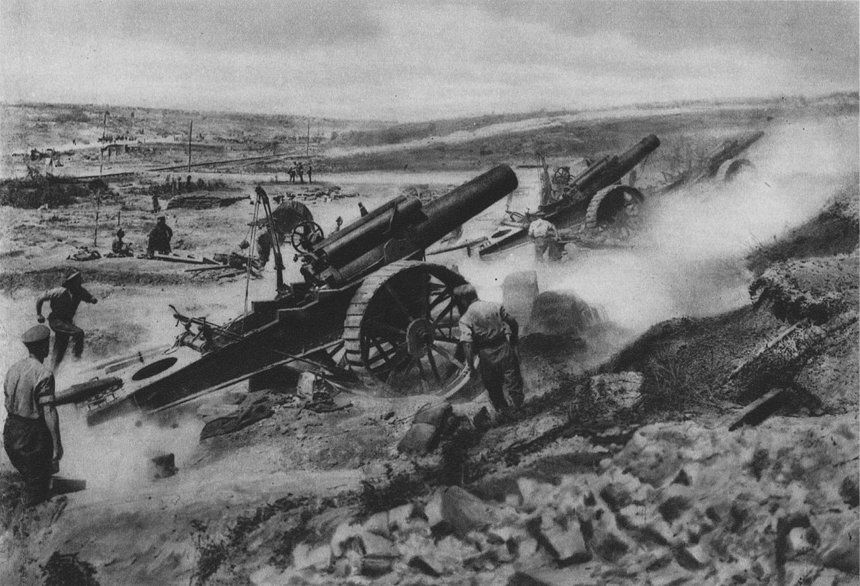
British artillery operating at the Battle of the Somme. (1916)
A. Prior Learning: How much do you already know about World War One?
In five minutes, write down as much as you can about what you think you know about World War One.

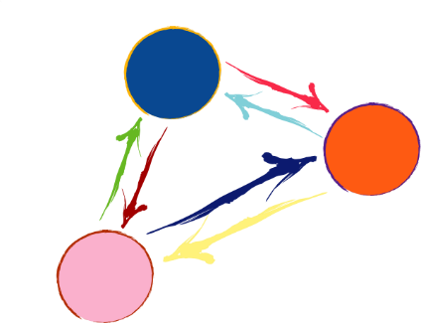
B. So what? Why are we learning about this?
Global Context
Identities and Relationships
Who am I? Who are we?
In this unit we are going to explore the relationships between and within states. In particular, we are going to examine how states compete and cooperate with each other and the factors that lead to these two different relationships. We live in a world of increasing competition (e.g. US-China) but also with systems of cooperation (e.g. United Nations, international law).
Key Concept
Global Interactions
This concept focuses on the interdependence of the larger human community, including the many ways people come into conflict and cooperate with each other.
Related Concepts
Conflict: When two or more groups fight or disagree about something. Conflicts are not always violent or end in war. Some conflicts may be nothing more than an argument or disagreement. However, some conflicts become lengthy and violent wars.
Power: A highly contested concept. Power often means the ability to make someone else do what you want. However, this may not be true in all cases. We will examine some different interpretations of power in this unit.
C. Reflection: What are some causes of conflict between countries through space and time?

World War One Quick Fact Sheet
Use the Oversimplified video on the Wordpress and an internet search engine to find some basic information about the First World War.
- When did World War One start and finish?

- How many people died in the war?

- Which countries fought in the war?

- How did the war start?

- WWI is considered by many historians to be the first “modern war”. Why do you think that is?

E. Inquiry Question: What caused the First World War?
Most historians recognize that there are four major causes of World War One. These can be remembered easily by using the acronym MAIN. They are listed below;
- M___________________
- A___________________
- I____________________
- N___________________
We will start by learning about _____________________!
E. The Congress of Vienna [Roleplay]
- Working with a group of four you will represent one of the five countries present at the Congress of Vienna; Austria, Prussia, Great Britain, France and Russia.
- After reading your description you must meet with the other groups to discuss what to do with the territories occupied by Napoleon. In other words;
  - What territories do you want to obtain?
  - What countries may be willing to work with you to achieve this goal?
  - Which countries are you working against? In other words, who are you trying to oppose or stop from achieving their goals?
- As a class come up with an agreement of who will get what territory. You will need the support of at least two (2) other countries to get what you want.
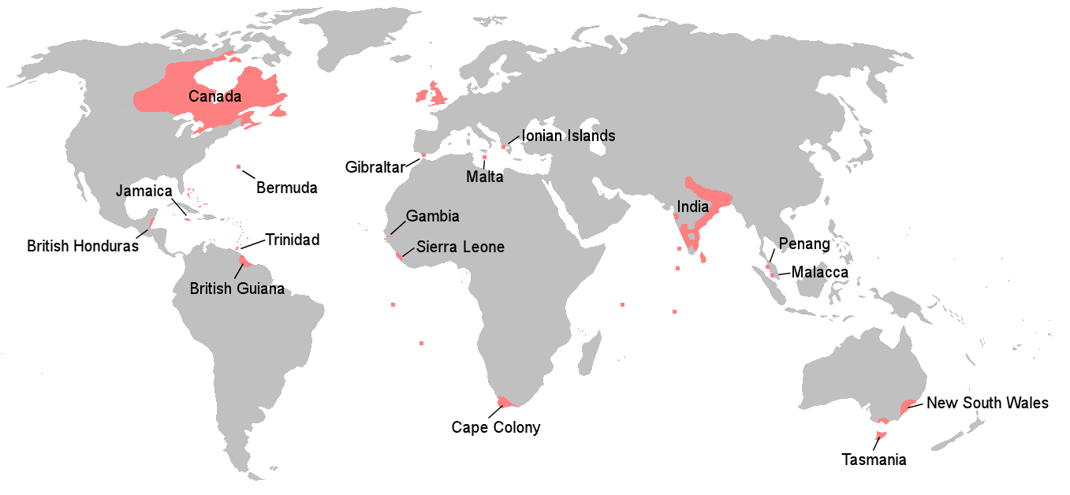

The British Empire in 1815
F. Balance of Power Video
- What is the first way that states (countries) can achieve a balance of power?

- What is the second way that states (countries) can achieve a balance of power?

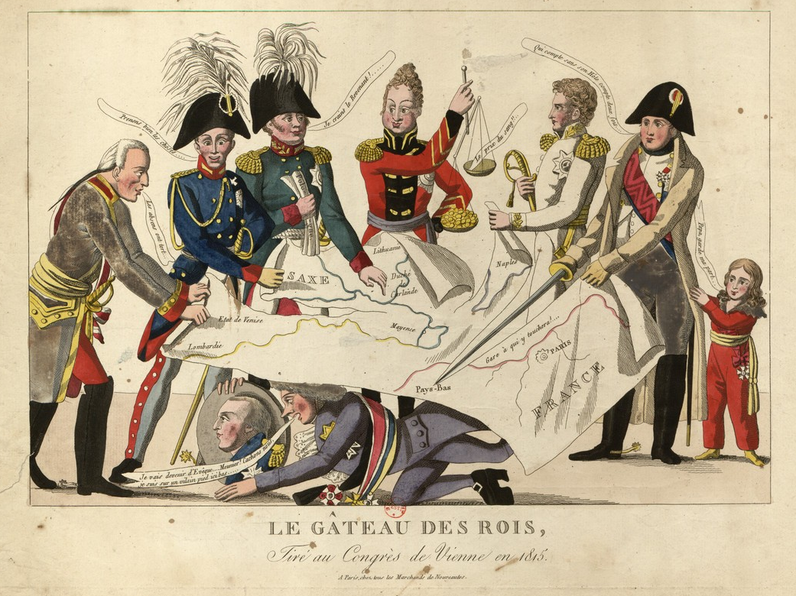
- Does balance of power maintain peace or does it lead to war? Discuss (D.I).

