The Estates General of 1789
Inquiry Question: What caused the French Revolution in 1789?
B. Summer of 1789 Timeline

C. Film: The French Revolution
1. “For the people of France in the 18th century, ________ is the essence of life itself. __________, the measure of existence.”
2. “Under Louis’ financial mismanagement the cost of flour skyrockets. Sparse food supplies are hoarded. The cost of a loaf of bread soon equals a __________ earnings (salary).”
3. Why is Louis’ new finance minister, Jacques Necker, popular with the people of France? What does he ask Louis to do in 1789?

4. “The deputies [of the Third Estate] declare themselves a new National Assembly, the true representatives of the ____________ of France.”
5. What does the King do in response to the declaration of the National Assembly? Why do you think he does this?

6. “By early July, ___________ of the King’s troops are taking positions around Paris. To defend themselves, the people form a new _______________. Rioters raid Paris’ armories, making off with 28,000 muskets (type of g1un). The only thing missing is _______________, and the people know just where to get it.”

7. “The Bastille had been a great symbol of _________ despotism, a symbol of the Kings of France running beyond the just limits of their power, a symbol of _________ for the people of France.”
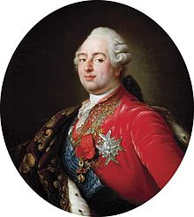
Is it a revolt?

8. What did the people of Paris do to the commander of the Bastille? How do you feel about this?

9. What do the people of Paris do to the Bastille after they capture it? Why do you think they did this?

Bonus: What did Louis XVI write in his diary on July 14th, 1789? _______________
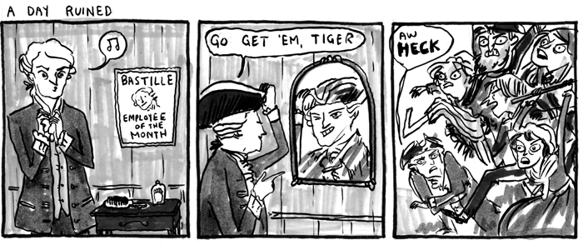

Beaton, Kate. “French Revolution Comics.” Hark! A Vagrant, www.harkavagrant.com/index.php?id=273. Accessed 1 Dec. 2016.

