You are the First Estate
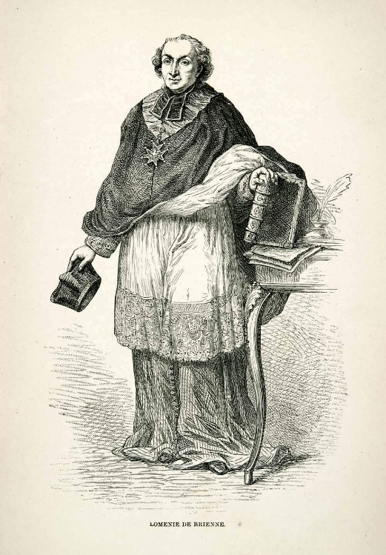
You are the Catholic clergy! At the Estates General you are mostly made up of commoner priests. However, some of you are wealthy cardinals and bishops.
Together, the Church has the power to tax members of the Third Estate.
You also own a lot of land in France.
The Church is also responsible for supporting the divine rule of the King. You support the system of the divine right of kings.
In return, the King agrees not to collect taxes from you.
The King also often selects a senior member of the clergy to serve as his ministers, like Étienne Charles de Loménie de Brienne (pictured to the right) who was the finance minister of Louis XVI from April 1787 to August 1788.
Above all, you want to maintain the power and position of the Catholic Church in France. You are, after all, responsible for maintain the power of the King and getting the souls of the French people into heaven.

You are the Second Estate
You are the French nobility! At the Estates General you are made up of powerful and influential nobles from across France. You believe you are very important and have special powers and privileges and that you have had these powers for hundreds of years. You often call these your “ancient privilege” because you have held them for so long.
A special privilege you enjoy is freedom from royal taxation. The King has always agreed not to tax the nobles.
However, you have the power to collect taxes from the peasants and commoners who live on your lands. You also lead the King’s armies in war and often serve as his government ministers
Although you have fought against the King’s power in the past, you now recognize that you need him to protect the ancient privileges you still enjoy.
Overall, you want maintain your special place in French society. Whatever decision is made at the Estates General, it must not make the nobility disappear!
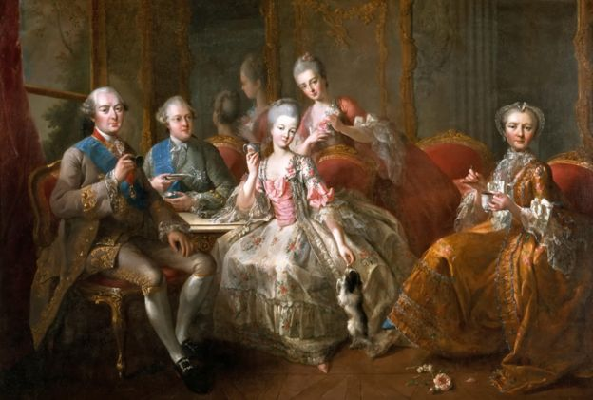
The Third Estate
You are the commoners of France! Although this represents about 95% of the French population, the people at the Estates General are quite wealthy. Most of the Third Estate deputies at the Estates General were lawyers and were literate (could read and write). Many others were businessmen and traders who also were literate.
You pay taxes to the King, the Church and to your landlords. However, some of you are also landlords yourselves and you collect tax from peasants and other commoners.
Despite this, you have been influenced heavily by the Enlightenment and you believe that true political power must come from a nation’s people. Because you represent the largest portion of the French people you believe you are responsible for representing them.
Because you are equal in size to the other two estates put together you believe that the Estates General should vote by head instead of by estate. If you did this then some members of the First and Second Estates might join you.
Overall, you want the Estates General to be truly representative of the people of France and that decisions made at the Estates must have the consent and agreement of the people of France. This issue must be settled before we can talk about money and finance.
