Economic Conditions in France
Film: The French Revolution
1. How does the video describe King Louis XVI? Was he a good king? Why or why not?

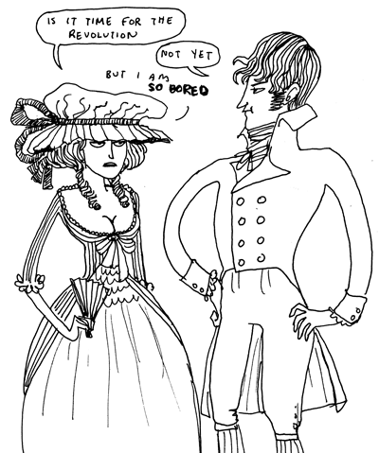
2. “The grand wedding gala continues for days, but outside the gates of Versailles there is hardly cause for celebration. Years of mismanagement by the monarchy, have left the French people deprived and ____________.”
3. King Louis XV lost the Seven Years War. What effect did this have on France?

4. “France grew from _____ million to _____ million in the 18th century, after having grown only ____ million in the previous two centuries. That put tremendous strain on what was there and that caused a lot of anxiety.”
5. “The Enlightenment is a movement which says don’t _______ authority, don’t trust anything you’ve been told by anyone else. Think it for yourself, test it for yourself.”
6. What did Louis XVI do when the American Revolution began? What effect did this have on France?
Source: Kate Beaton, Hark a Vagrant!
A Look at the Evidence: Travels in France (1792) by Arthur Young
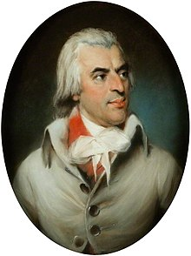
OPVL: When studying an event in history it is important to look at primary sources. These are usually first-hand accounts of a time in history, written by people who experienced the period you are studying. Most of what we know in history is uncertain, but what we do know about the past comes from our primary source material. However, primary sources are imperfect. To use primary sources properly, we need to consider their origin, purpose, value, and limitations (OPVL).
Origin: Who was Arthur Young? What type of person was he? Use your computer to find some information about this person in history.

Purpose: Why did Arthur Young write Travels in France in 1792? What kind of document was it? Is it fiction or non-fiction?
Criteria D: Thinking Critically
iii. Evaluate sources of information in terms of origin and purpose, recognizing value and limitations.

Travels in France, published in 1792 by Arthur Young
“
[September 1788] To Montauban. The poor people seem poor indeed; the children terribly ragged, - if possible, worse clad than if with no clothes at all; as to shoes and stockings, they are luxuries. A beautiful girl of six or seven years playing with a stick, and smiling under such a bundle of rags as made my heart ache to see her. They did not beg, and when I gave them anything seemed more surprised than obliged. One third of what I have seen of this province seems uncultivated, and nearly all of it in misery. What have kings, and ministers, and parliaments, and states to answer for their prejudices, seeing millions of hands that would be industrious idle and starving through the [terrible commands] of despotism, or the equally detestable prejudices of a feudal nobility. Sleep at the Lion d'Or, at Montauban, an abominable hole.
[July 12 1789] Walking up a long hill to ease my mare, I was joined by a poor woman, who complained of the times, and that it was a sad country. Demanding her reasons, she said her husband had but a [small piece] of land, one cow, and a poor little horse, yet they had [18 kg] of wheat and three chickens to pay as a [tax] to one [landlord]; and four [72 kg] of oats, one chicken, and one franc, to pay to another, besides very heavy tailles [the tailles was a specific property tax in France] and other taxes. She had seven children, and the cow's milk helped to make the soup."But why, instead of a horse, do not you no keep another cow?" Oh, her husband could not carry his produce so well without a horse; and [donkeys] are little used in the country. It was said, at present, that something was to be done by some great folks for such poor ones, but she did not know who nor how, but God send us better, car les tailles et les droits nous ecrasent.
This woman, at no great distance, might have been taken for sixty or seventy, her figure was so bent and her face so furrowed and hardened by labor, but she said she was only twenty-eight. An Englishman who has not traveled cannot imagine the figure made by infinitely the greater part of the country women in France; it speaks, at the first sight, hard and severe labor. I am inclined to think that they work harder than the men, and this, united with the more miserable labor of bringing a new race of slaves into the world, destroys absolutely all symmetry of person and every feminine appearance. To what are we to attribute this differences, in the manners of the lower people in the two kingdoms? To government . . .”
Value: What does Young describe in these quotations? Why might his book be of value to a historian of the French Revolution? What does he tell us about life in France before the Revolution?

Limitations: Is there something that Young does not tell us? Do we have any reason to distrust his account? Could he be lying or does he have any reason to lie?

Conclusion: Evaluate the source. In other words, is this a good source of information about the French Revolution? Why or why not?
Evaluate: Make a judgement or appraisal by weighing strengths and limitations. In other words, judge the quality of something.

Approaches to Learning: Chunking
ATL: Read critically and for comprehension.
One helpful strategy for paraphrasing and summarizing information is chunking. To do this, you read a paragraph or section of a text, then stop and paraphrase/summarize the main idea in your own words. Afterwards, you move on and read the next paragraph.
Follow the graphic organizer below to use chunking to read “Harvest Failures” on the next page.
“Harvest Failure”
Paragraph | Summary of main idea (in your words!)
#1
#2
#3
#4
#5
#6
Summary Questions:
1. To what extent was France vulnerable to poor harvests? What role did climate and weather have on this?

2. What were the consequences of food shortages on the people of France?

Making Connections
Based on what you already know about pre-revolutionary France, what might have made the misery of 1788-1789 worse for peasants and urban poor in France?

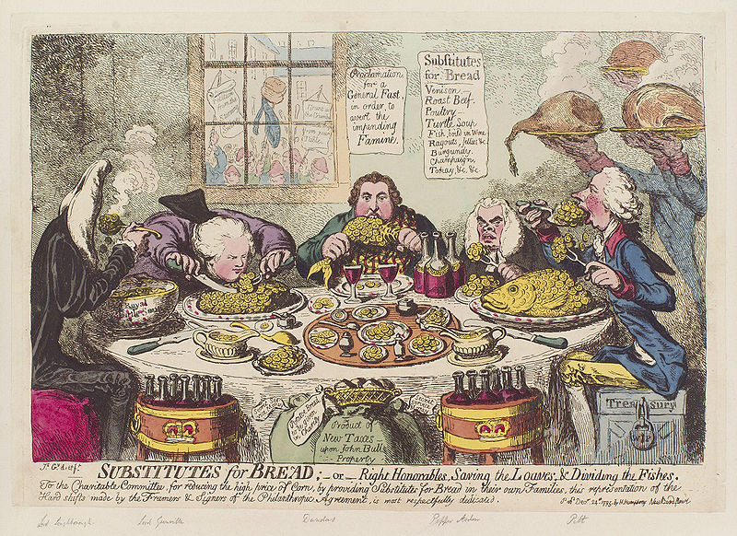
Sign on the wall reads: “Proclamation for a general fast, in order to avert the impending famine.” Source: Cartoon from 1795

A town in southern France.
The Lion d’Or is likely a small hotel. Arthur Young calls it an “abominable hole”, meaning it is a pretty awful place to sleep.
Translation from French; “The weight of the taxes crush us!”

