Note-Taking
While other groups are presenting you should record some important information. You can use the spaces below or write it in your notebook/computer. The choice is yours.
Note: Your notes should help you answer the questions on the first page.
First Estate
Second Estate
Third Estate

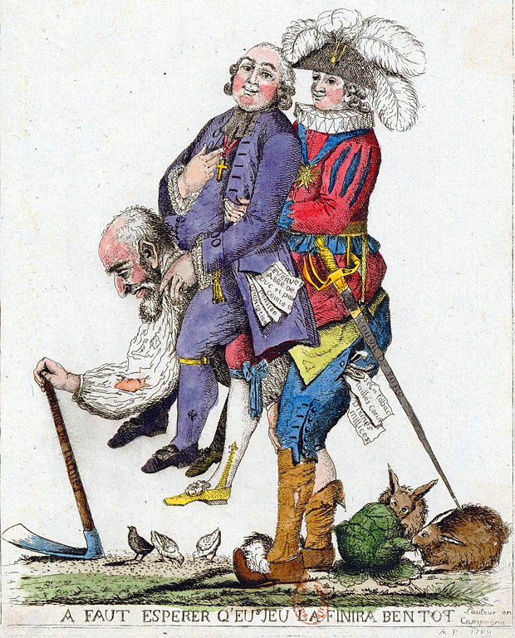
Reflection Question
What are your thoughts on the society of orders? Does this seem like a fair system? Do you think some people deserve powers and privileges that others don't? Submit your answers as an "exit ticket" on Managebac.

